

American International University- Bangladesh

CSC 3222: Web Technologies

CO1.1 and CO2.1 Evaluation

Project Report

Spring 22-23

Project Title: TAX MAGNIFIER

Section: G

Group No: 01

|  |  |
| --- | --- |
| Student Name | Student Id |
| MINHAZ AHMED AYON | 20-41859-1 |
| SHITHI ROY | 19-41545-3 |
| TASIN HASAN RAHE | 19-41008-2 |

**Introduction:**

One of the most important aspects of having our website is we have direct access to the Tax Payer by email addresses, and contact numbers. We can send them email marketing, offer discounts on paying taxes, and announce new policies. Handling all the employees is much more difficult in nowadays because we don’t have direct access to our employees. This gives opportunities to provide good customer service and promote. Not only do we have records also know how much they paid, and what facilities they want from us. You can use this information to influence and suggest future tax paying and make a good forecast plan for the future of the company.

**Background Study:**

Website References

* **BDTAX.COM.BD**: bdtax.com.bd is the first online tax preparation, processing and submission software for Bangladesh. With bdtax.com.bd you can easily prepare your tax, get reviewed by expert tax consultants and submission to NBR by BDTax team. It is a system guided easy-to-use tax preparation software that will save you time, money and help you reduce any tax potential audits by the Government.

From this website we have seen the structure of the website and also what kind of services they have been providing through their websites. Other than this, we have also looked at many other websites such as nbr.gov.bd, e-tin.bd etc. We have got some ideas from these websites and now we will try to implement them in our project.

**Requirement Analysis**:

1. **User Category:**

There are 4-types of Users here. They are:

* Admin
* Manager
* Employee
* Customer

1. **Feature List:**

In this project the “Admin” has the following features:

* Create Account
* Log In
* Log Out
* Profile view
* Select Manager

In this project the “Manager” has the following features:

* Create Account
* Log In
* Log Out
* Employee Profile view
* ADD Employee
* REMOVE Employee
* Update Info
* Increment Salary
* Decrement Salary
* Review Customer Rating

In this project the “Customer” has the following features:

* Create Account
* Log In
* Log Out
* Pay Tax
* Check Tax Amount
* Complain
* Give Ratings

**ER Design:**

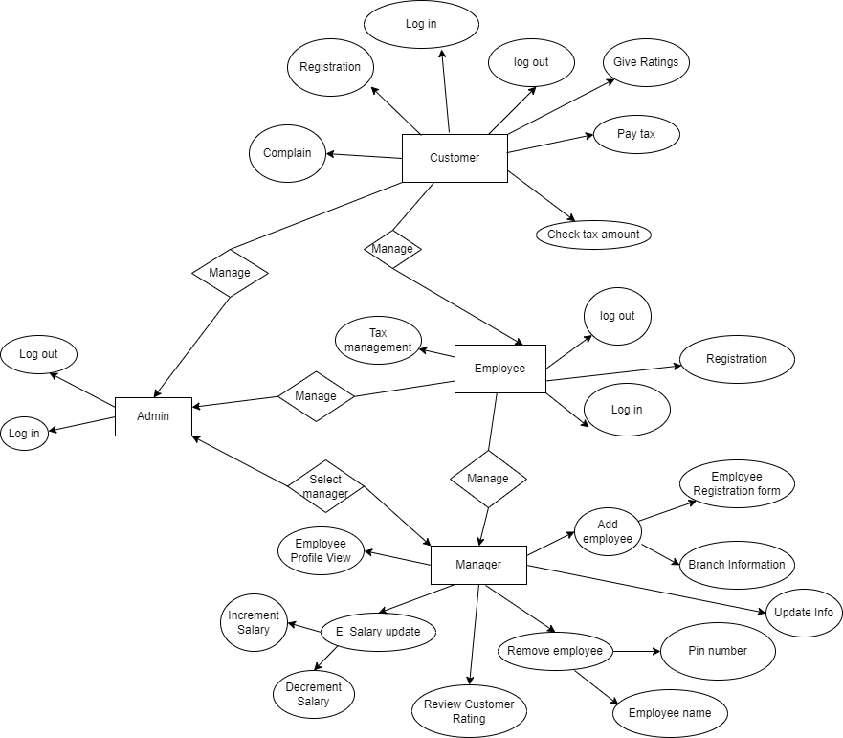

**Tools Used:**

To develop this project, we have used the following:

* + Visual Studio Code
  + XAMPP Control Panel v3.3
  + Diagrams.net
  + Google Chrome Browser

**System Images against the Specification:**

This is a temporary UI of what we are working on Manager User.

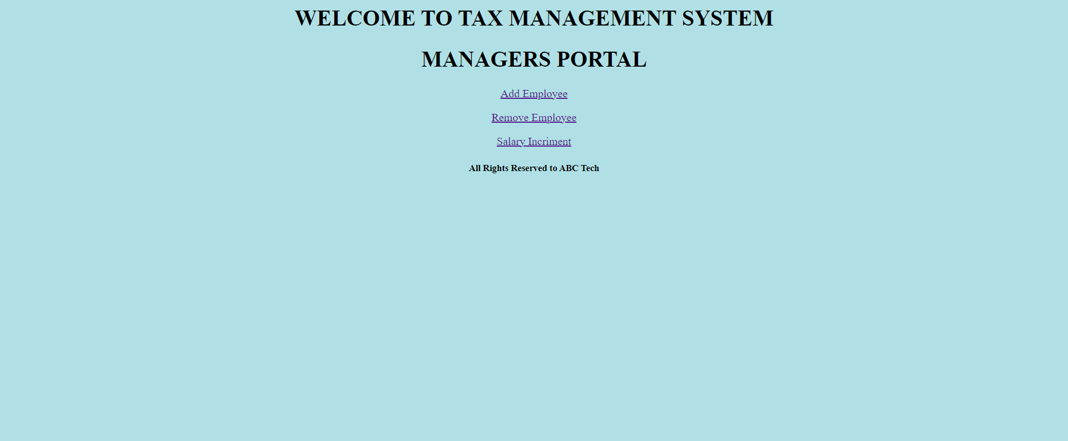

Fig: 01

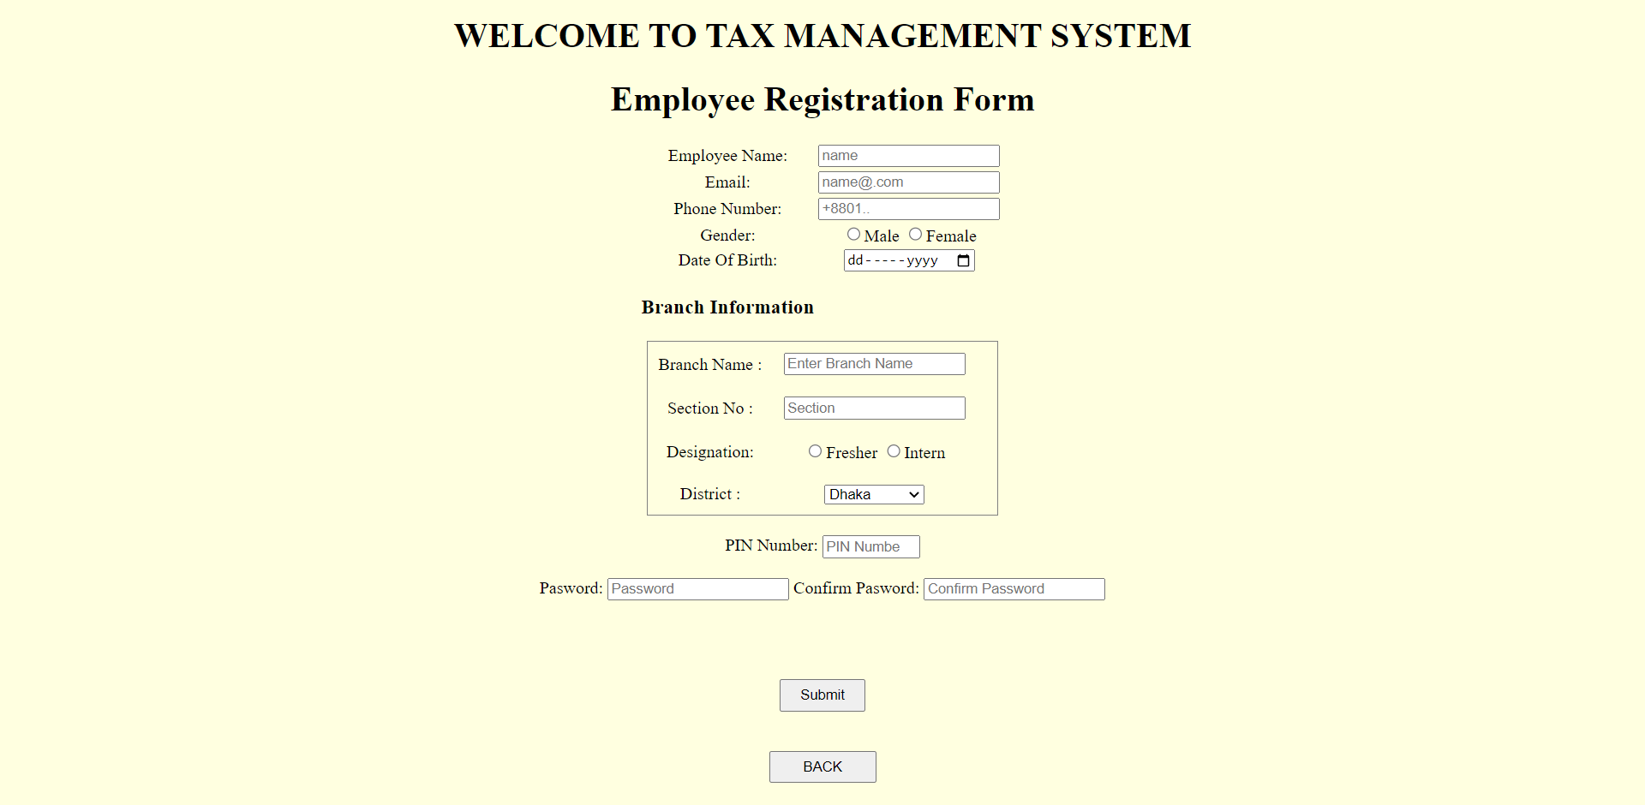

Fig: 02

**Impact of this Project:**

The most telling impact of our project has been the ease of people paying their taxes quite easily. This will also have a huge impact on employees. Before this they have to from one place to another to collect taxes. But now they don’t have to take any kind of bother.

Tax payer can pay tax safely through this website from their home.

Limitations and Possible Future Improvements. With the help of these online site anyone can pay their taxes from anywhere in the country.

|  |  |  |  |  |  |
| --- | --- | --- | --- | --- | --- |
| CO1.1 and CO2.1 Evaluation: Project Report Evaluation | | | | | |
| Project Proposal  (5) | Background  Study  (5) | Requirement Analysis  (5) | Entity  Diagram  (5) | System Images  against the  Specification (5) | Total (25) |
|  |  |  |  |  |  |
|  | | | | | |